## Front End Engineering-II

Project Report

Semester-IV (Batch-2022)

Title of the Project: -

Veterinarian Clinic Website

**Supervised: Submitted By:**

Raveesh Samkaria Rydhampreet Singh Gindra

Roll Number: -2210990751

Group - 12

**Department of Computer Science and Engineering**

## Chitkara University Institute of Engineering & Technology,

## Chitkara University, Punjab

**Abstract**

This project report outlines the creation of a front-end website for a Veterinarian Clinic, utilizing HTML, CSS, and JavaScript. The website encompasses essential clinic information, team profiles, service packages, and contact details. With a focus on user engagement and seamless navigation, the website aims to effectively communicate the clinic’s offerings and expertise to potential clients. Through responsive design and accessibility considerations, the project underscores the clinic’s commitment to delivering exceptional digital experiences.

**Table of Contents**

|  |  |  |
| --- | --- | --- |
| Sr.no | Section | Page No |
| 1. | Introduction | 4 |
| 2. | Problem Statement | 5 |
| 3. | Technical Details | 7 |
| 4. | File Structure | 8 |
| 5. | Result | 9 |
| 6. | References | 41 |

**Introduction**

In today's digital era, establishing a robust online presence is vital for veterinary clinics to effectively showcase their services and connect with their target audience. Thus, the creation of an engaging and user-friendly website holds paramount importance, especially for veterinary clinics aiming to highlight their expertise and compassion in the competitive industry landscape. This report outlines the development and implementation of a front-end website for a veterinary clinic, employing a blend of HTML, CSS, and JavaScript.

The website serves as a virtual doorway for the clinic, providing visitors with an insightful glimpse into its services, veterinary team, patient care philosophy, and contact details. Through strategic design elements and intuitive navigation, the website endeavors to captivate visitors and communicate the clinic's unique brand identity and commitment to animal welfare effectively.

This introduction offers an overview of the project's objectives, stressing the significance of a well-crafted website in today's digital veterinary domain. Following sections will delve into the technical intricacies of website development, spotlighting key features, design nuances, and implementation tactics. Moreover, the report will address encountered challenges during the project and the innovative solutions devised to surmount them, presenting valuable insights for future veterinary clinic website endeavors. Ultimately, this project underscores the fusion of design and technology, showcasing the clinic's dedication to delivering exceptional digital experiences to its clients and animal companions.

**Problem Statement**

In the realm of veterinary clinics, establishing a compelling online presence is vital for attracting prospective clients and showcasing the clinic's unique services and compassionate care. However, creating a front-end website that effectively communicates the clinic's brand identity, range of services, and commitment to animal well-being while ensuring a seamless user experience presents several challenges.

Firstly, veterinary clinics often encounter difficulty in finding the right balance between showcasing their expertise and ensuring the website's functionality. While it's crucial to highlight the clinic's compassionate approach and veterinary expertise through engaging content, it's equally essential to ensure that the website is easy to navigate and provides clear, informative details to visitors.

Secondly, designing a responsive website that adjusts seamlessly to various devices and screen sizes is a significant challenge. With the increasing use of smartphones and tablets, users expect a consistent and optimized browsing experience across all platforms. Failure to deliver this may result in potential clients seeking services elsewhere and may undermine the clinic's credibility.

Additionally, ensuring accessibility for all users, including those with disabilities, is another pressing concern for veterinary clinics. Adhering to accessibility standards is essential to ensure that the website is usable by individuals with diverse needs, such as providing options for larger text sizes or compatibility with screen readers for visually impaired users.

In summary, the problem statement revolves around the need to create a front-end website for a veterinary clinic that effectively balances showcasing expertise with functionality, offers seamless responsiveness across devices, adheres to accessibility standards, and optimizes performance to provide an exceptional user experience. Addressing these challenges will be crucial in achieving the project's objectives and ensuring the success of the clinic's online presence.

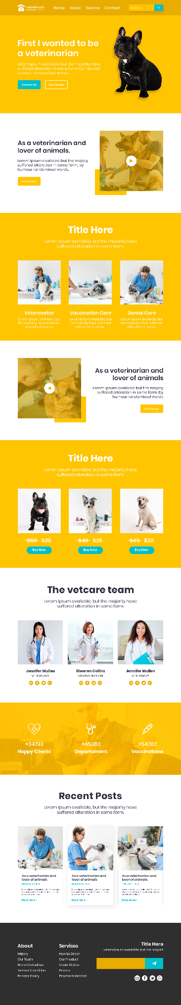

**Technical Details**

The front-end website for the veterinary clinic was meticulously developed with a minimalist approach, utilizing only essential technologies to guarantee a seamless user experience. Here are the key technical details of the project:

* **HTML Structure:** The website's structure was meticulously crafted using semantic HTML markup to enhance accessibility and clarity. Each page was organized with appropriate tags, facilitating intuitive navigation and readability for visitors.
* **CSS Styling:** Cascading Style Sheets (CSS) were employed to style the layout, typography, and color schemes of the website. Custom CSS rules were implemented to maintain a cohesive visual design throughout the site while prioritizing fast loading times and code simplicity.
* **Responsive Design:** Responsive design principles were integrated to ensure the website's adaptability to various devices and screen sizes. Media queries and flexible layouts were employed to responsively adjust content and design elements without relying on external frameworks.
* **JavaScript Functionality:** JavaScript was selectively used for essential functionality, primarily for enabling smooth scrolling to different sections of the website via the navigation bar. This lightweight implementation ensured optimal performance without compromising the overall user experience.

**File Structure: -**

* **index.html:** This file serves as the main entry point for the website. It contains the HTML markup defining the structure and content of the web pages. Within this file, sections such as the header, navigation bar, main content area, footer, and any additional elements are defined.
* **index.css:** The CSS file contains the styling rules that dictate the visual presentation of the website. This includes defining colors, fonts, layout properties, and any other stylistic elements. Selectors within this file target specific HTML elements or classes to apply the desired styles.
* **index.js**: This JavaScript file contains the client-side scripting logic for the website. In this minimal setup, the primary functionality includes hamburger menu and certain other minor things.
* **assets folder:** This folder contains all the assets used throughout the website. Assets may include logos, background images, or any other visual assets required to enhance the design and content presentation. Proper organization within this folder helps maintain the clarity and accessibility of image resources.
* **PSD file**: This PSD (Photoshop Document) file contains the original design mockup created using Adobe Photoshop. While not directly utilized in the website's development, it serves as a reference for design elements, layout, and visual styling.

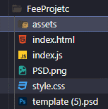

**Result**

Webpage Screenshots: -

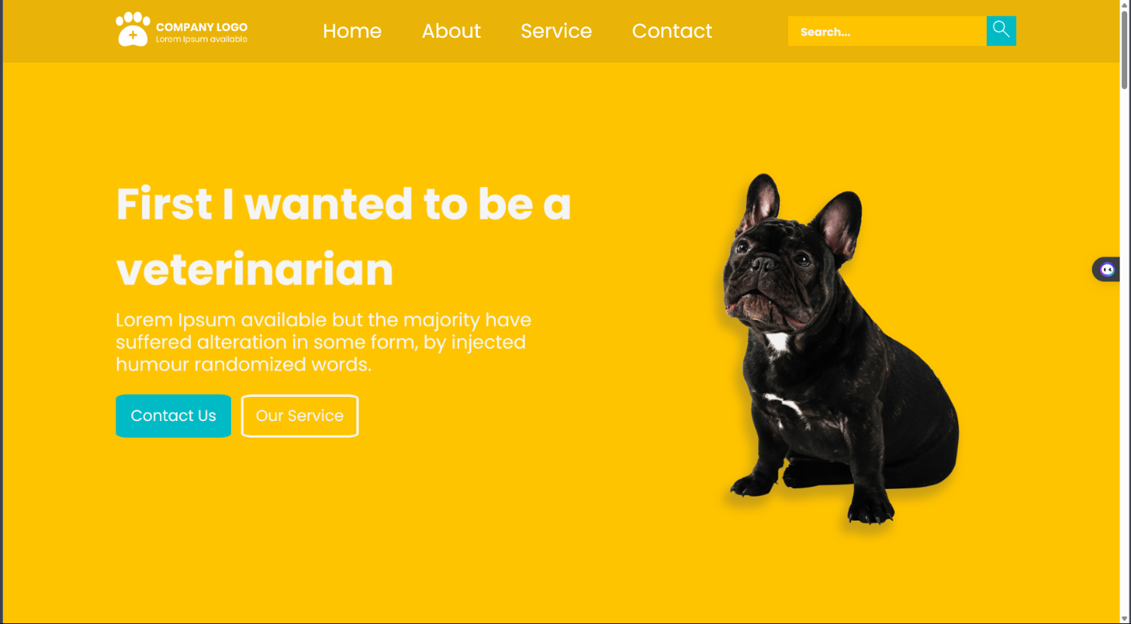

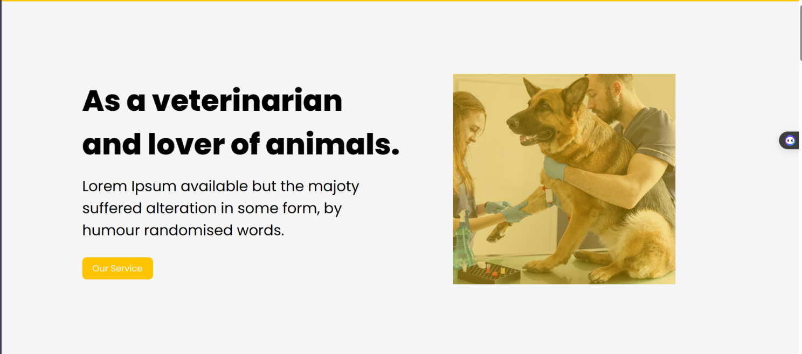

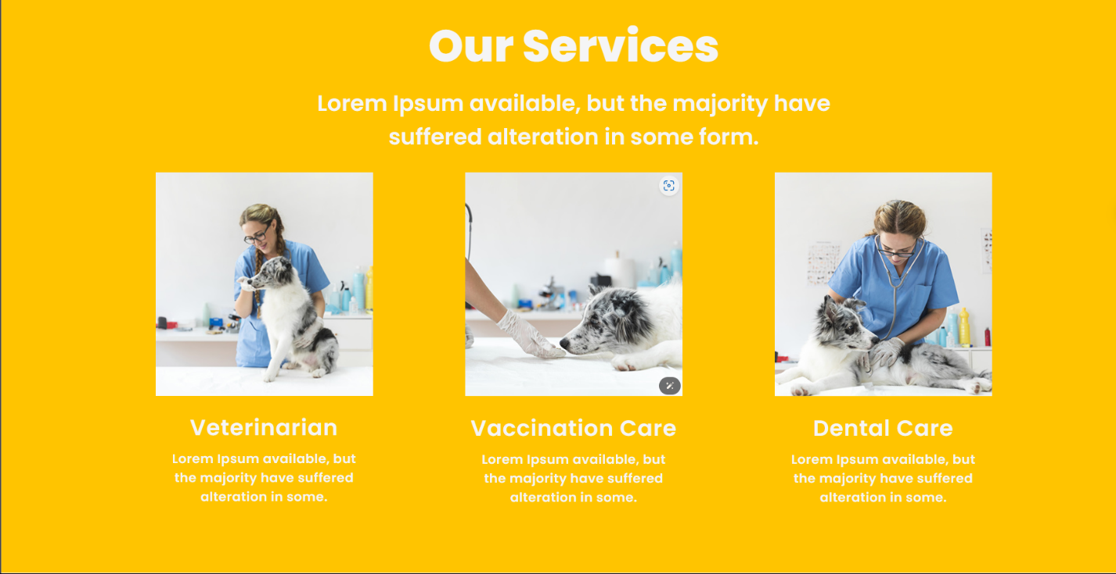

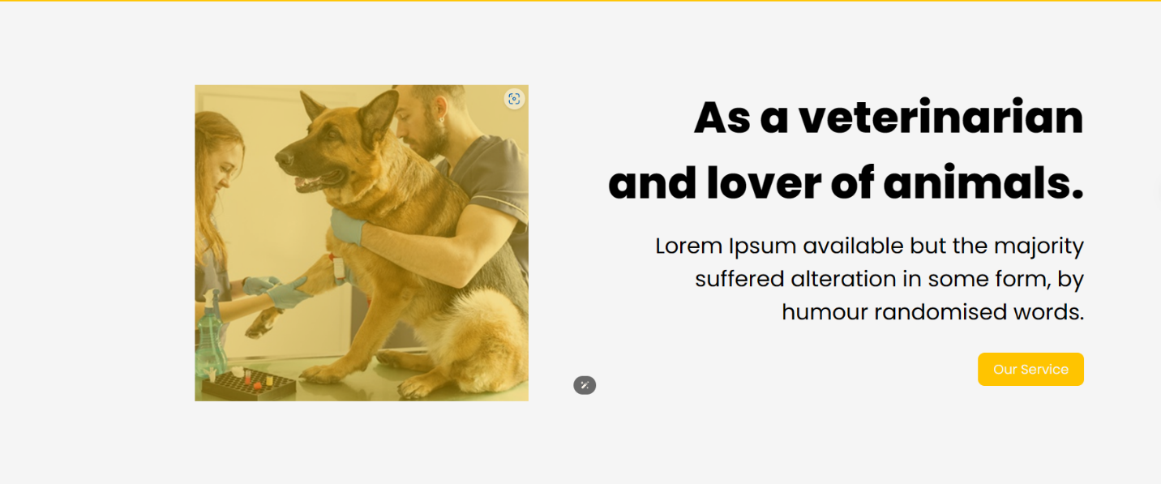

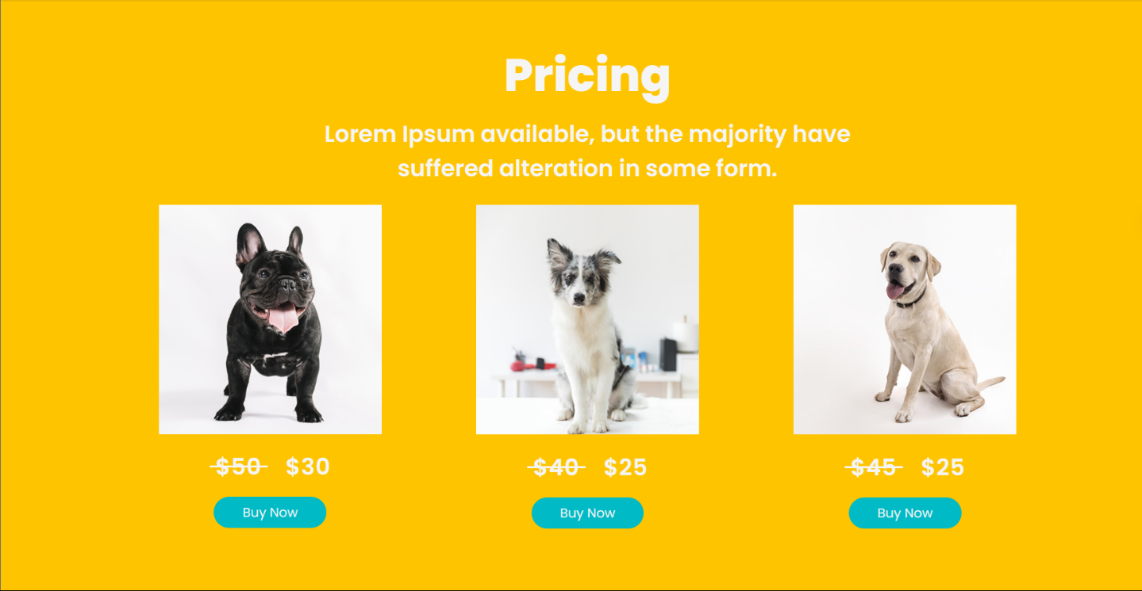

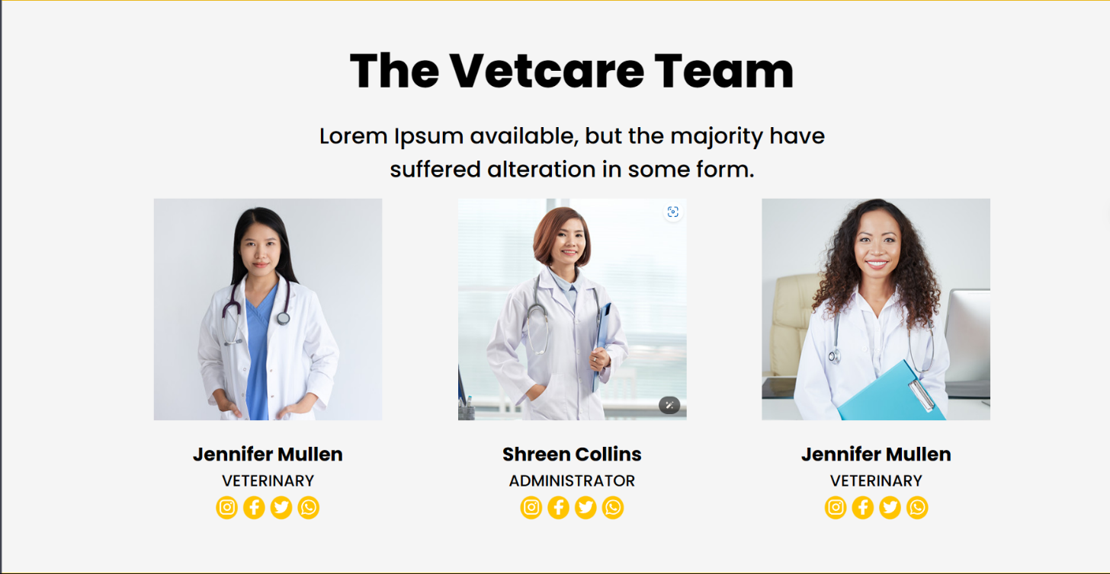



**Code:-**

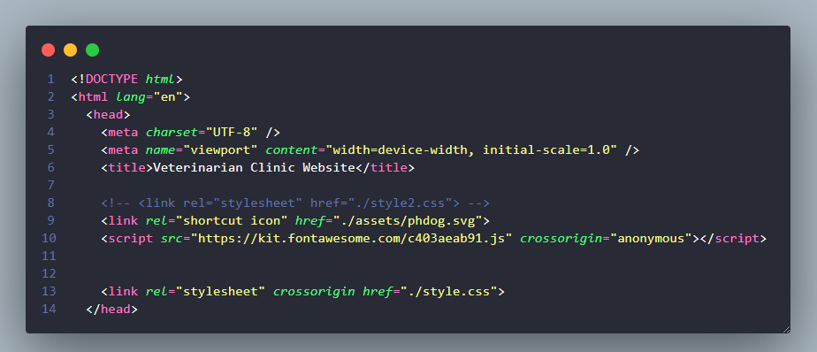

**Figure 1 Head Tag**

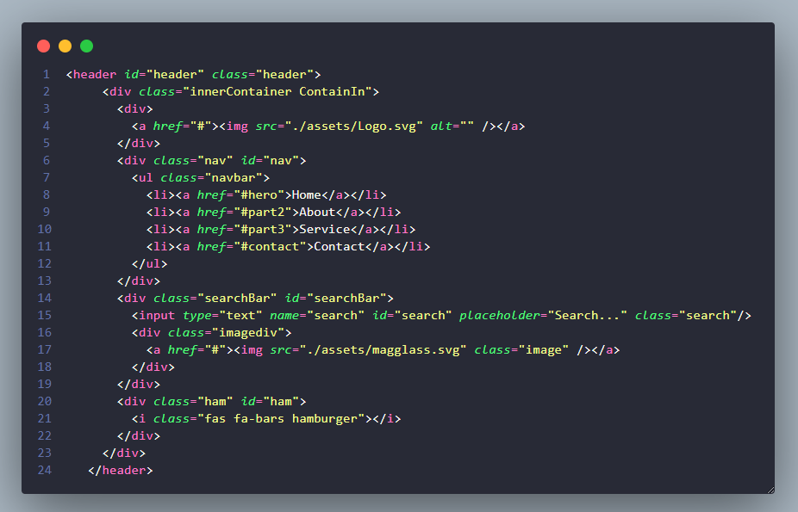

**Figure 2 HTML- Header Section**

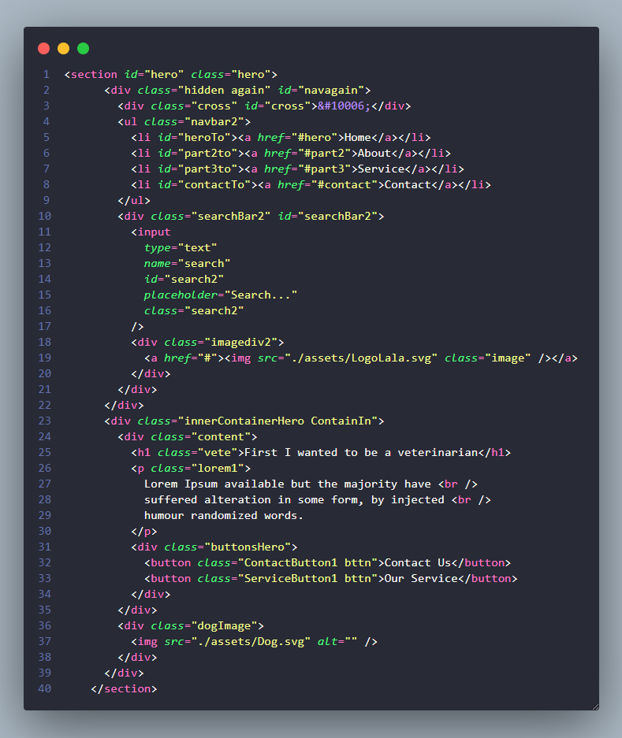

**Figure 3 HTML - Hero Section**

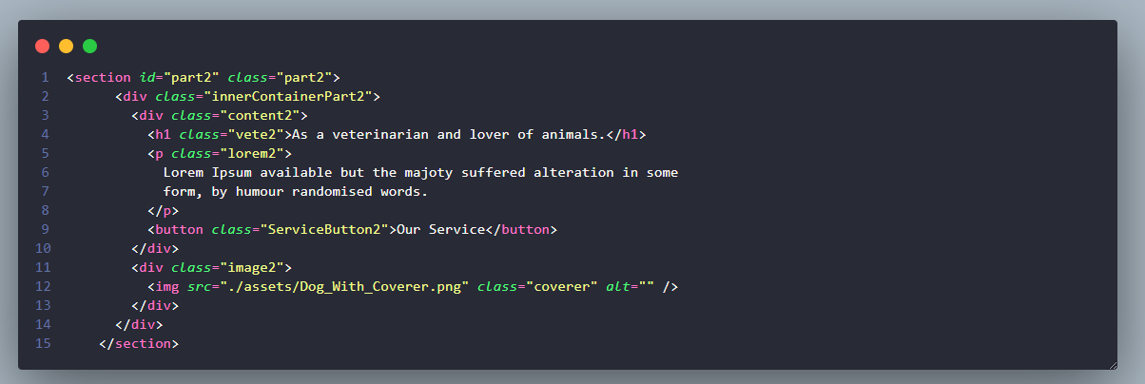

**Figure 4 HTML - Part 2**

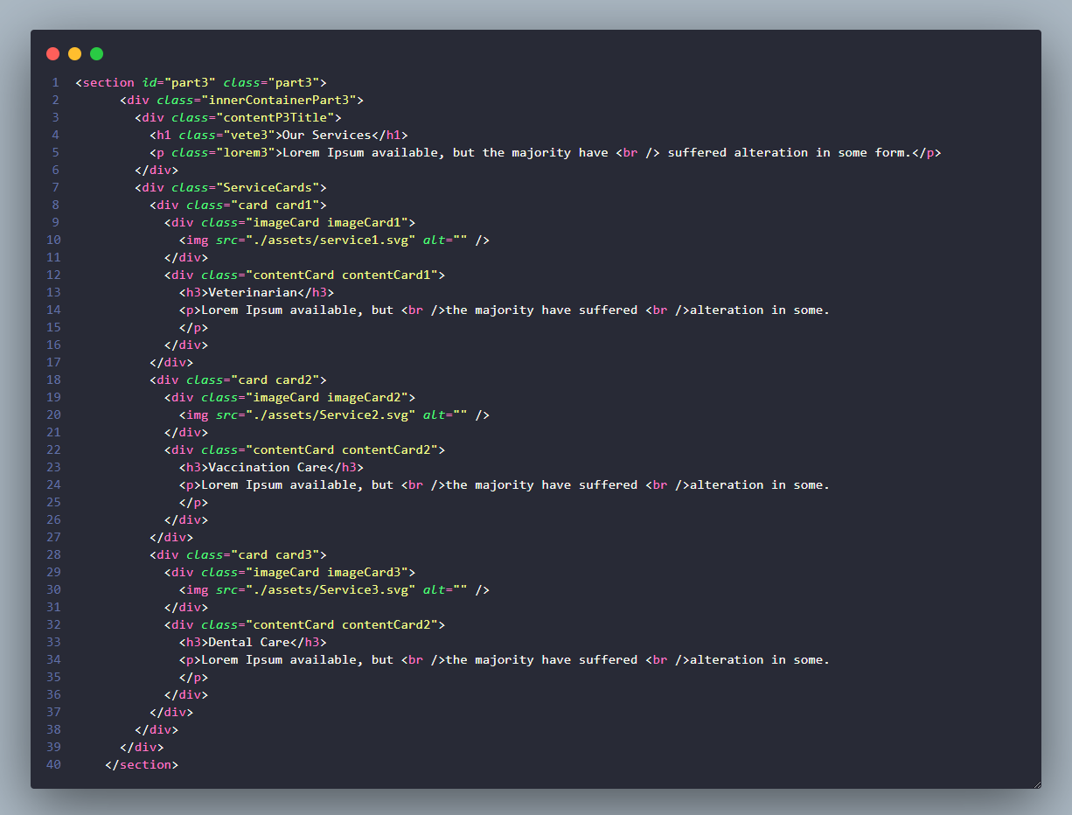

**Figure 5 HTML – Part 3**

**Figure 6 HTML – Part 4**

**Figure 7 HTML – Part 5**

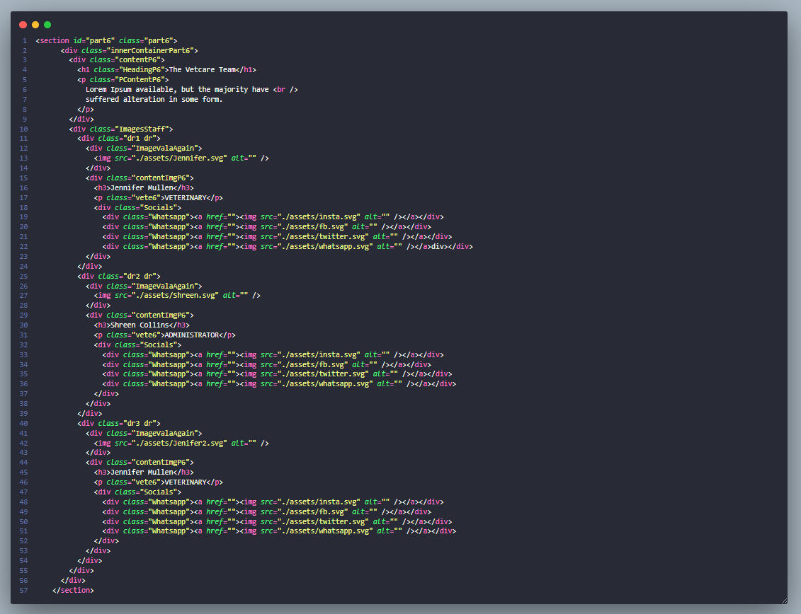

**Figure 8 HTML – Part 6**

**Figure 9 HTML – Part 7**

**Figure 10 HTML – Part 8**

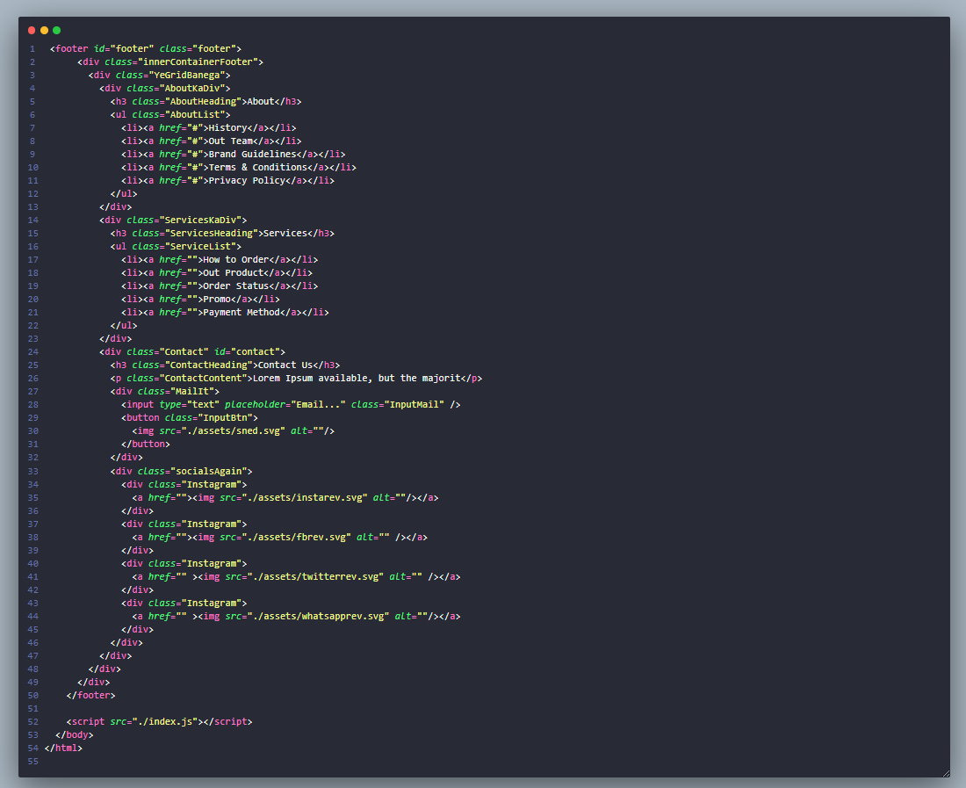

**Figure 11 HTML – Footer and Script Link**

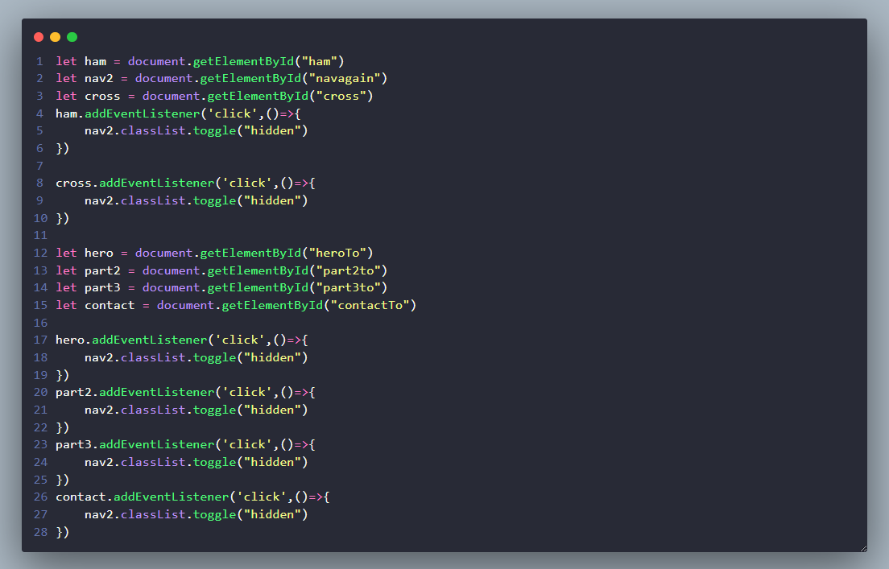

**Figure 12 Javascript**

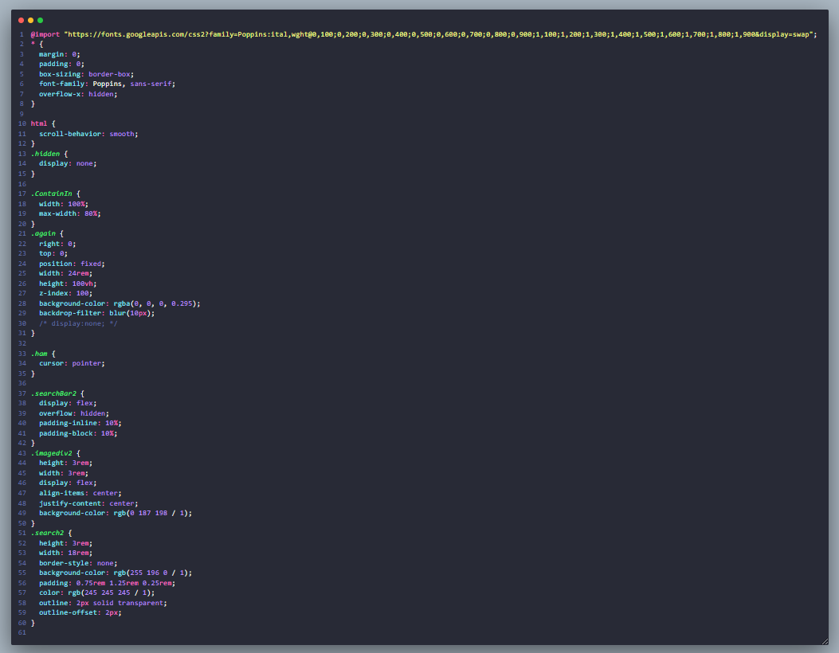

**Figure 13 CSS**

**Figure 14 CSS**

**Figure 15 CSS**

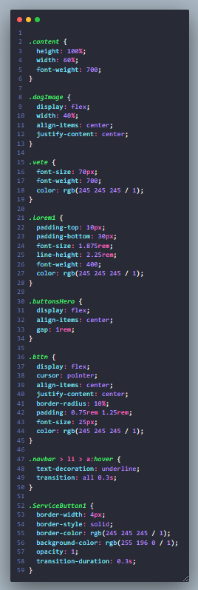

**Figure 16 CSS**

**Figure 17 CSS**

**Figure 18 CSS**

**Figure 19 CSS**

**Figure 20 CSS**

**Figure 21 CSS**

**Figure 22 CSS**

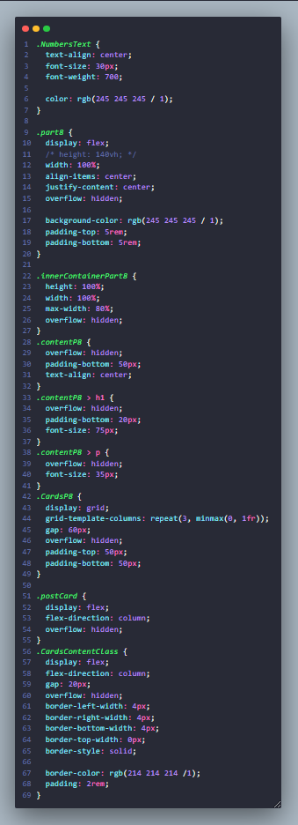

**Figure 23 CSS**

**Figure 24 CSS**

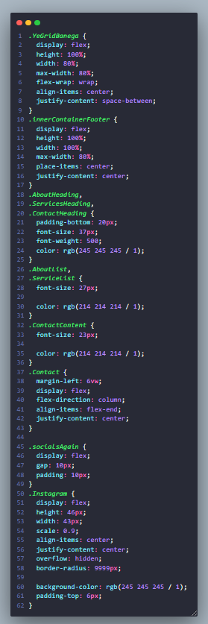

**Figure 25 CSS**

**Figure 26 CSS**

**Figure 27 Media Query**

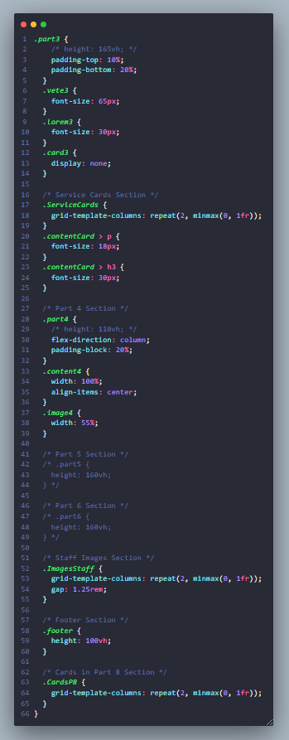

**Figure 28 Media Query**

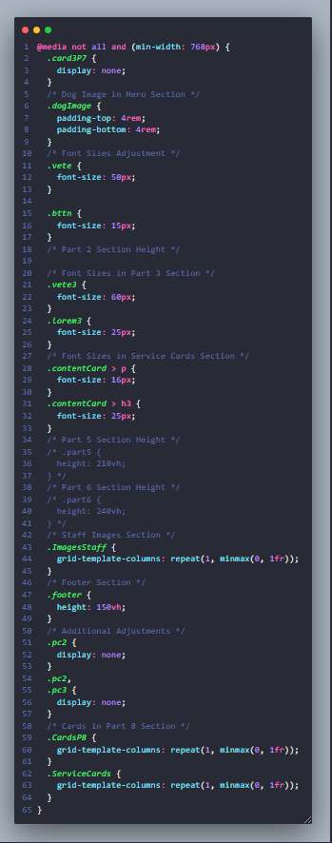

**Figure 29 Media Query**

**Figure 30 Media Query**

**References**

1. [www.photopea.com](http://www.photopea.com)
2. [www.w3schools.com](http://www.w3schools.com)
3. [www.figma.com](http://www.figma.com)
4. <https://fonts.google.com/>
5. <https://developer.mozilla.org/en-US/>